**Software Engineering**

**Assignment**

**MODULE: 1**

**SE – Overview of IT Industry**

1. **What is software? What is software engineering?**

**Ans.** Software is a set of instructions, data or programs used to operate computers and execute specific tasks.

Software engineering is the branch of computer science that deals with the design, development, testing, and maintenance of software applications.

1. **Explain types of software**

**Ans.** A)Application software B) System Software C) Driver Software

D) Middleware Software E) Programming Software

1. **What is SDLC? Explain each phase of SDLC**

**Ans.** The systems development life cycle (SDLC), also referred to as the application development life cycle, is a process for planning, creating, testing, and deploying an information system.

1. Requirements gathering and analysis: This phase involves gathering information about the software requirements from stakeholders, such as customers, end-users, and business analysts.
2. Design: In this phase, the software design is created, which includes the overall architecture of the software, data structures, and interfaces. It has two steps:

High-level design (HLD): It gives the architecture of software products.

Low-level design (LLD): It describes how each and every feature in the product should work and every component.

1. Implementation or coding: The design is then implemented in code, usually in several iterations, and this phase is also called as Development.

Things you need to know about this phase:

This is the longest phase in SDLC model.

This phase consists of Front end + Middleware + Back-end.

In front-end: Development of coding is done even SEO settings are done.

In Middleware: They connect both the front end and back end.

In the back-end: A database is created.

1. Testing: The software is thoroughly tested to ensure that it meets the requirements and works correctly.
2. Deployment: After successful testing, The software is deployed to a production environment and made available to end-users.
3. Maintenance: This phase includes ongoing support, bug fixes, and updates to the software.

**4.What is DFD? Create a DFD diagram on Flipkart**

**Ans.** A data-flow diagram is a way of representing a flow of data through a process or a system (usually an information system). The DFD also provides information about the outputs and inputs of each entity and the process itself. A data-flow diagram has no control flow — there are no decision rules and no loops. Specific operations based on the data can be represented by a flowchart.

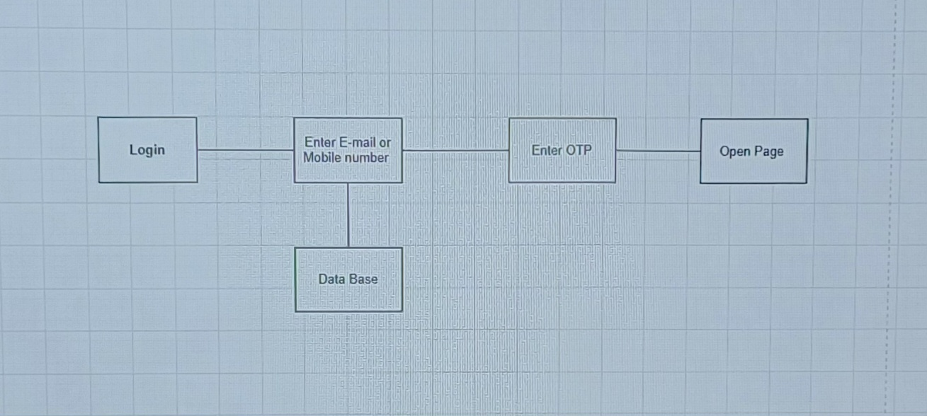

**5. What is Flow Chart? Create a Flowchart to make addition of Two Numbers**

**Ans.** A flowchart is a type of diagram that represents a workflow or process. A flowchart can also be defined as a diagrammatic representation of an algorithm, a step-by-step approach to slowing task.

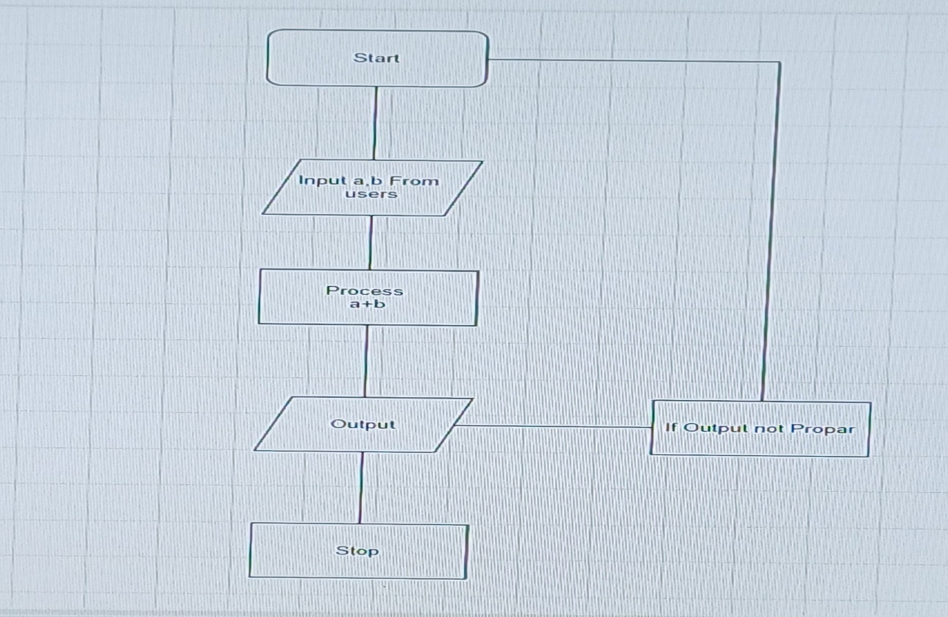

**6. What is Use Case Diagram? Create a use case on bill Payment on Paytm.**

**Ans.** A use case diagram is a graphical depiction of a user's possible interactions with a system. A use case diagram shows various use cases and different types of users the system has and will often be accompanied by other types of diagrams as well.



